OpenAVRc

An open source RC transmitter based on the ATMega 2560 AVR microcontroller from ATMEL / Microchip
Wiring the MegaMini © Version 2.1 Shield
Copyright OpenAVRc 2018
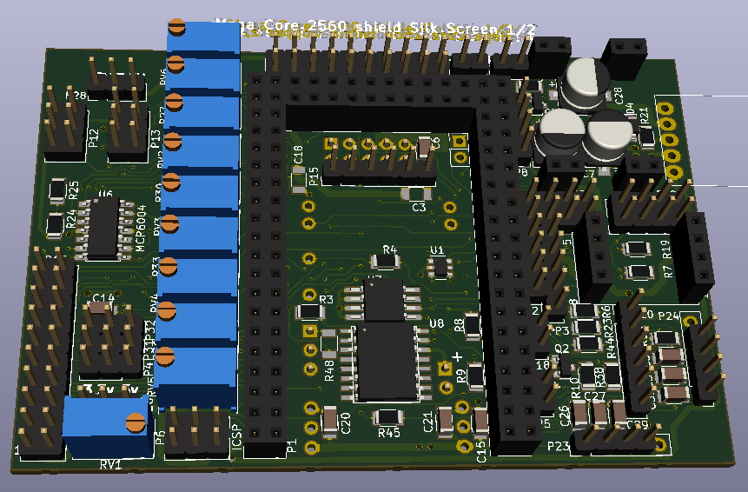

This circuit is intended for the mega2560-Core from Inhaos


Advice :
We suggest that you read and reread this document and let it sink in before the building starts.
Prefer a "function by function" construction and test and verify the correct functioning before moving on to the next phase.
Suggested order of construction
- Power supplies and stick connectors
- Stick amplifier
- Setting up the different connectors
- Screen and Core circuit
At this point, you can then start your radio after using the document "OpenAVRc_V3 Software Manual"
- SD card
- JQ6500
-etc
To wire up the circuit, one can also consider a second method, namely
- power supply
- mounting one of the screens
- setting up the 3 connectors of the Core
- configuration of the Core circuit based on the document "Software Manual"
- implementation of the Core
- power up! And verification of operation
- continued wiring

Document versions
Version | Date | Reason for Change
0.1 | 17/10/2021 | Creation of V2.2

2 Copyright
This document is Copyright © 2018 OpenAVRc.

3 Caution
The OpenAVRc team is not responsible for damages that may arise from the misuse or possible malfunction of the OpenAVRc transmitter
It is therefore up to the end user to measure, assume the risks and comply with the legislation in force depending on the country of use.

Graphical charter :
Note
Info
Warning   | Warning 1: The first pre-wired circuits of version 2.1 were delivered with the vibrating circuit diodes wired upside down. (D1, D2 and D3).  It is necessary to invert them if you want to use the vibrator. If not, simply remove them.  See the correct direction of assembly of these diodes pages 6 or 33.Attention

Warning | Warning 2: A circuit connection error was found in the telemetry section on the version 2.1 shields.  See pages 13-14 for correction. This change is not necessary if you are using a DC or multimodule HF circuit.

4 Table of contents
Document versions 3
2 Copyright 3
3 Caution 3
4 Table of contents 4
5 Module wiring and connector locations: 6
5.1 Diagram of the Power supply section: 7
5.2 Common supply (LI-Ion) : 7
5.2.1 Solution 1 : L4940 or 4941: 8
5.2.2 Solution 2 : (PM-5033) 8
5.2.3 Solution 3 : (MP1584em) 8
5.3 Wiring of different connectors 9
5.3.1 P12 and P13 Sticks: 9
5.3.2 P1, P2 and P3 Potentiometers: 9
5.3.3 P16 Parallel LCD screen: 10
5.3.4 P9 ICSP connector: 10
5.3.5 P11 Trim Connector: 10
5.3.6 P14 Switch Connector: 11
5.3.7 P25 key connector : 11
5.3.8 P19 connector, telemetry and PPM output to HF module: 11
5.3.9 P23 and P24 Rotary encoder connectors: 12
5.3.10 P5 vibrator connector: 12
5.3.11 P15 I2C LCD Display Connector: (SSD1306 ou SH1106) 12
5.3.12 P20 Wiring for the telemetry module, TTL / RS232 converter: 13
5.3.13 P6 SD card connector: 15
5.3.15 P22 JQ6500-28P sound module wiring: 15
5.3.14 P8 Audio-Buzzer / Voice signal connector: 16
5.3.16 P2 DS3231 RTC module and FRAM FM24W256-G connector: 18
5.3.18 P18 trainer connector: 19
5.4 Modules HF: 20
5.4.1 Module HF cc2500 jaune : 20
5.4.3 P7 Connections for the HF module 4 in 1 SPI: 21
5.4.4 Connections for the 5v / 3,3v level converter: 21
5.4.5 Connections for the 4 in 1 HF module: 21
6 Amplification of the stick signals: 22
6.1 Purpose for the stick amplification 22
6.2 Diagram of the stick Amplification 22
6.3 Adjustment of the stick adapters: 24
6.3.1 Method 1 24
6.3.2 Method 2 25
7 Screen preparation: 27
7.1 Recall pinout for P16 27
7.2 Screen Zollen (7565P) 27
7.3 Screen ARTRONIC (7565R) 28
7.4 Screen ST 7920 : 29
7.5 Screen KS108B : 30
7.6 Summary of Arduino, Ports, P16 and Display Connections 31
8 Appendices : 32
8.1 Remove the TTL / RS232 converter from the FrSky DHT module. 32
9 Placement of components : 33
10 Various Tips 34

5 Module wiring and connector locations:
Top side

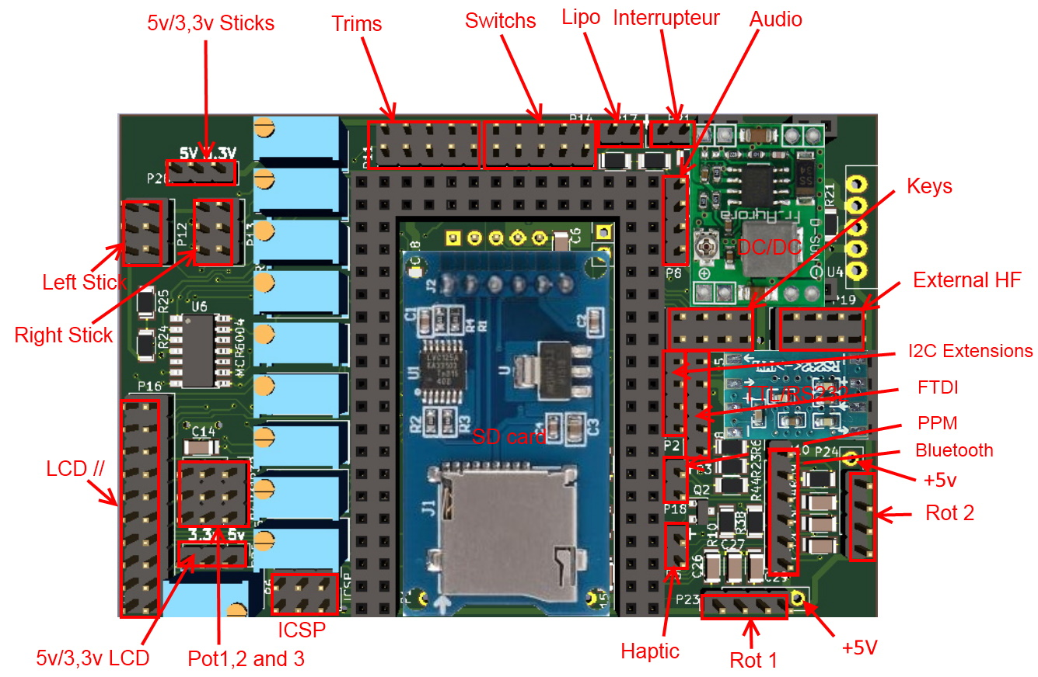
Bottom side
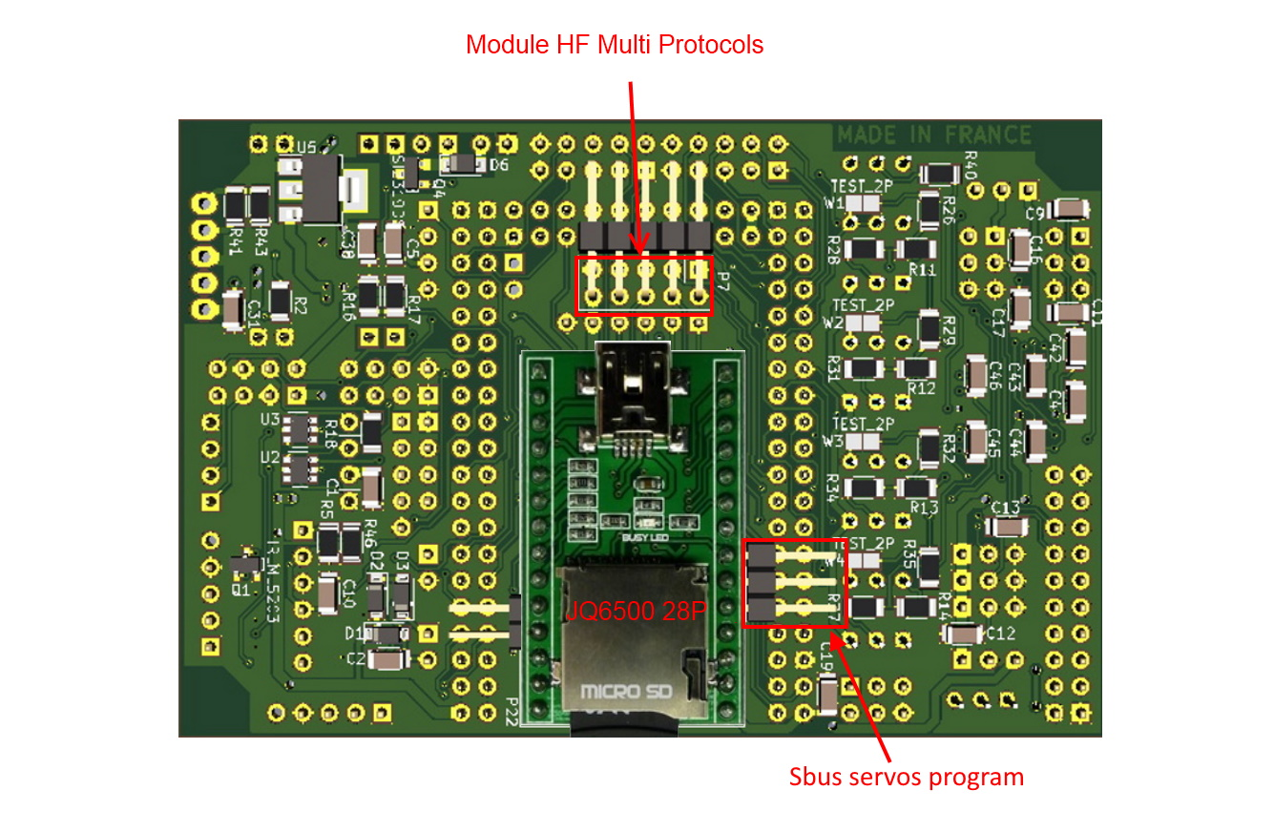

5.1 Diagram of the Power supply section:

The Power supply section includes:
- a common power supply battery (Lipo, LiFe, NiMh ...)
- a protection diode D6
- a switch circuit consisting of Q3, Q4 with power switch P21
- a circuit for measuring the battery voltage R16 and R17
- a 5V regulator (3 solutions)
- and possibly a 3.3V regulator if necessary for a screen or Hall stick depending on the type of 5V power supply you choose.


5.2 Common supply (LI-Ion) :


A LiPo battery or better, Li-Ion 2S or 3S (3 x 4.2v maximum) can be used to power the board.

+5 and + 3.3V Power Supply Circuits:

5.2.1 Solution 1 : L4940 or 4941:


This first solution uses a linear 5v L4940 series regulator whose efficiency is much worse than the two following solutions. The TO220 three-legged housing will be wired to tabs 2, 3 and 4 of U4.
In case 3.3V is needed (for Hall effect sticks), U5 must be soldered.

Warning | Except wanting to dissipate some heat, it is useless to use a 3S battery in this case!

5.2.2 Solution 2 : (PM-5033)


Here, the 5v AND the 3,3v are created by the PM-5033 from Inhaos (U4).
Very good performance at 96%, good
higher than the L4940 of solution 1, so less heat dissipation and longer battery life.
Do not solder U5 (3.3v), a 3.3V regulator is already mounted on the back of the IC.

5.2.3 Solution 3 : (MP1584em)

This last solution uses a DC / DC module ( switching power
supply, in place of the PM-5033 (U4).
Very good performance also at 96%,

Adjustment (if any) of the output voltage:
- Replace the variable resistor with a fixed resistance of 47K ohms in parallel with a resistance of 1M ohms.
For this value the output voltage is then 4.97V.

If 3.3V is needed then U5 should be soldered.

Warning | It is imperative to adjust this module to +5v maximum before soldering it on the circuit at the risk of destroying the active components that do not support more than 5V. In addition, the SSD1306 I2c screen will not start.

5.3 Wiring of different connectors

5.3.1 P12 and P13 Sticks:
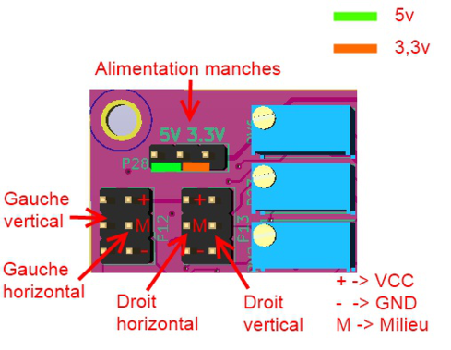
It is possible to turn the screw of each potentiometer to reverse the direction of movement.

By default, the shield is prewired for sticks with potentiometers powered by 5V.
There are sticks with Hall effect sensors that must be powered by 3.3V.
In this case, it will be necessary to replace a resistor on the divider bridge and one per channel,
(See page 22 "Stick Amplification P12 and P13: 5v / 3,3v").

Warning | For correct adjustment, the voltage will increase when the stick is operated from left to right or from bottom to top.  In the case an amp is being used, then the signal will be reversed, it will take this into account. This will be pointed out again in the settings.

Warning | Hall effect sleeves: It is almost certain that you will have to reverse the direction of movement of one of the two channels of each stick. For this, do not reverse the power supply (risk of destruction of the sensor electronics) but use the software reversal option described in the document "Software Manual" (Desktop)

5.3.2 P1, P2 and P3 Potentiometers:
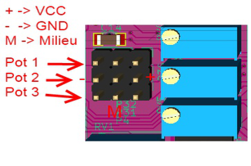

It is possible to turn the screw on each potentiometer to reverse the direction.

5.3.3 P16 Parallel LCD screen:


Position the RV1 potentiometer as shown in the diagram (turn to the right to be accessible if you put a jumper). See diagram page 5

For details on how to wire up screens connected in parallel, (Zolen, Artronic, ST7920 and KS108, see chapter 7, page 26)
Warning | Pay attention to the pin order for connector P16 on the connected cable (2,1,4,3, etc.) See chapter 7

5.3.4 P9 ICSP connector:



5.3.5 P11 Trim Connector:


5.3.6 P14 Switch Connector:



5.3.7 P25 key connector :
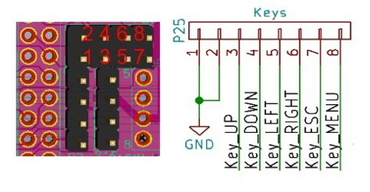

Each key will be connected between
one of the pins 3 to 8 and the common (GND).

5.3.8 P19 connector, telemetry and PPM output to HF module:



Warning | See the diagram in this section on page 13 for more explanations

5.3.9 P23 and P24 Rotary encoder connectors:


5.3.10 P5 vibrator connector:

5V

Warning | - Using a vibrator 3.3 v: Check the direction of the diodes because there was a screen printing and positioning error on the shield  -Using a vibrator 5 v: Do not wire both diodes and short circuit D2 D3

5.3.11 P15 I2C LCD Display Connector: (SSD1306 ou SH1106)


Warning | Check that the screen address is 0x78  (which corresponds to the write address 0x3C) !!!

5.3.12 P20 Wiring for the telemetry module, TTL / RS232 converter:

This Max3232-based module has two converters, one per side. Only the Max3232 side will be used.
The module has 4 small diameter holes for VCC and GND power supplies.
For its wiring, I advise you to solder two
strips of 4 pins (see first remark next page, following the error on the circuit) by centering the pins on the holes as well as the centers of the SMD pads without drilling them because that would generate a short circuit with the SMD pin from below.

Solder two female connectors on the shield, then plug the module and its connectors as specified (pins 1 and 8 down).
This cabling solution, intended for FrSky telemetry, will allow this module to be easily replaced by another type of assembly for another telemetry format.

Note | If you are using a FrSky DHT module, you have the option of removing the internal TTL / RS232 converter from the module, which becomes useless (see appendix). Note that in this case, a firmware update of the HF module is no longer possible.  If you want to upgrade to the EU version, this must be done first.
Here is the diagram of the entire telemetry chain:

Warning | If you want to use a PPM HF module on which you will receive the telemetry signals, it is necessary to correct a link error on the shield.    If you do not intend to use the FTDI P2 jack, the easiest way is to wire the TTL RS232 converter as follows to swap the signals from pins 5 and 6:  Otherwise, at present R19 goes to U3 and R7 to U2 (dotted diagram)  To do this, you will need to desolder and reposition as you please the two resistors R19 and R7 to obtain the following diagram.  Look out, the tracks are fine and fragile!


FTDI connector to permanently leave a
USB-serial converter in your radio.
Two electronic inverters flip the pins
MEGA to the telemetry connector or this one
according to the power supply: Battery or USB.

5.3.13 P6 SD card connector:


The SD card is connected under the Core.
The ideal is to desolder the angled connector and replace it with a straight connector soldered from the bottom of the SD card, or to provide a removable mounting of the card, just in case!
Note:
A R 220 ohm must be added to the MISO circuit after intersected the trace

5.3.15 P22 JQ6500-28P sound module wiring:
You will use this module if you want to benefit from voice announcements from the function
"Voice", to indicate flight times, telemetry values, the selected flight phase,
transmitter battery voltage, etc.
Voice announcements will be stored in the module's micro SD memory.
The JQ6500-28P (28 pins) module comes with two 14-pin strips already soldered.


Note the presence of the Outputs Speaker Out + and -, allowing to directly connect a SP of 0.8W max

To be mounted correctly on the circuit, the module must be prepared . The pins circled in red should be kept but all other pins must be cut off.

Note | Another solution is to desolder the unused pins, so there is no risk that a unused pin touches a track of the shield!
The module will be mounted on the shield’s solder side (bottom) and soldering made on the component side (top). Note: Except the JQ, all these R and C components are already wired.

5.3.14 P8 Audio-Buzzer / Voice signal connector:



Summary of possibilities:

Without Audio function selected in Desktop

In this case, the buzzer connected between 1 and 4 will be used to indicate any action performed on a key or indicate an alarm, depending on the configuration chosen in the radio for this function.
- If the "Voice / JQ6500" function is enabled in "Desktop", pin 2 provides a signal from the JQ for voice announcements.

With Audio Function selected in Desktop


This mode of use is the smartest in our opinion
In this case, output 1 generates a simulated Buzzer signal as well as the sounds of the "Audio" function caused by pressing a key, a trim control, etc., depending on the choice made in the radio.
As before, if the "Voice / JQ6500" feature is checked in "Desktop", pin 2 provides a signal from the JQ6500-28P for voice announcements.
It will be necessary to use an amplifier (2w) described below, and whose printed circuit is also illustrated and available, to mix the Audio and Voice signals for sending to the 8 ohm speaker.

Mixing amp (Component Iist available)

It will be necessary to make a mixer assembly for the Audio-Buzzer and Voice signals before amplifying the signals to an 8-ohm loudspeaker.
If you do not want to use the "Audio" function and use a single buzzer, ("Audio" unchecked in Desktop), while using the Voice function ("Voice" checked in Desktop), only the connection to the JQ (pin 2 ) will be necessary and you will not need the mixing section.
As an option, a jack (3.5mm mono jack socket) can be added to connect a headset.
The resistance of 220 Ohms will be adapted to your hearing. The ideal first step is to use a variable resistor of 1Kohms to find your ideal setting, then replace this resistance with a fixed resistor of similar value.

Diagram of the mixing section + LM386 amp.

Note: The component references have nothing to do with the shield.



You can also make your adaptation using commercial audio amplifiers, based on LM386 or PAM8302 (class D) or any other mono amp.
A power of 2w is sufficient.

Or use "our" amp OpenAVRc


5.3.16 P2 DS3231 RTC module and FRAM FM24W256-G connector:



Initially this part was to connect by your self. On the version 2.1 shield it has been preconnected.


As a result, the P2 connector is free and can be used for any I2C extension.

The board therefore includes from the start
- On the one hand, an F-RAM memory FM24W256-G bringing the memory capacity for the models
to 32 KB.
To date, only 16 KB are used
- a DS3231 RTC clock circuit (Real Time Clock) and as a bonus a temperature sensor.

Info | F-RAM advantages: more memory space, faster and greater tolerance to multiple writes.

The back of the circuit board has a connector for a CR2032 battery (saves the time after transmitter is turned off).


5.3.18 P18 trainer connector:
The training can be done according to two methods,
- by cable or
- by Bluetooth (not functional right now).

Training with cable:
Just bring a ppm signal to the corresponding (+) input


Traing via Bluetooth:
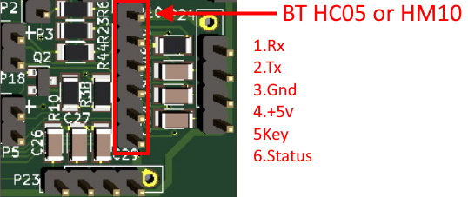

The Bluetooth module HM10 is configurable as master or slave.
The teacher module will preferably be configured as a master and the student preferably as a slave.
For a better differentiation of the modules, we can for example agree that the name of a teacher module starts with MAMONNOM (master) and the name of the student by ELMONNOM (student).
A led (blue?) Can be connected to the tab STATUS. It will then be connected in series with a 180 ohm 1 / 4w resistor.

5.4 Modules HF:

5.4.1 Module HF cc2500 jaune :

If you only use FrSky receivers, prefer the following CC2500 module that has a proven track record.


5.4.2 Wiring of the 5v / 3,3v level converter:
The input outputs only accept 3.3v signals. It is ESSENTIAL to separate this module from the Core using a 4-channel converter (MOSI, MISO, CS, SCLCK) which receives 0-5v level signals and converts them into 0-3,3v level signals. and vice versa for the MISO signal.



The printed circuit board (available) will allow mounting in a smaller area.
It is connected to P7 (see page 21) .



5.4.3 P7 Connections for the HF module 4 in 1 SPI:


The wiring will be done, preferably from below (soldering made from above).
The 4-in-1 multi-protocol module is powered by 5V. The input / outputs only accept 3.3v signals. It is therefore ABSOLUTELY necessary to separate this module using a 5v / 3.3v signal level converter.
This converter receives 0-5v level signals and converts them into 0-3,3v level signals.

5.4.4 Connections for the 5v / 3,3v level converter:



5.4.5 Connections for the 4 in 1 HF module:


6 Amplification of the stick signals:
Info | This pre-wired option (except the 8 potentiometers) allows a better definition of the channel signals because it uses the entire measurement range of the analog to digital converter of the MEGA-CORE board.

6.1 Purpose for the stick amplification
Tension
A stick produces a voltage varying proportionally with the angle of rotation.
The purpose of the amplifier part is to obtain at the analog inputs of the Core a voltage varying from Mini = 0V to Maxi = + 5V
The point "center" (neutral of the stick) is characterized by a voltage of + 2.5V with potentiometers powered by 5V and + 1.65v (approximately) with Hall effect sensors powered by 3.3V,
For this purpose, we have two potentiometers, which we will call "center or zero" (marked RV) and "slope or gain" (R)
Max
Pente

Centre
-100 %
+100 %
Déplacement
du Manche

Mini

Info | We noticed significant differences between different potentiometers, less with Hall effect sticks.

6.2 Diagram of the stick Amplification


Some technical explanations:
Technical info | Although the Core converter only works on 10 bits (1024 points), the FW software, through two successive conversions, generates an 11-bit signal (0000 to 07FFh) which theoretically means that 2048 different values can be be applied to servomotors.  These values will be displayed in the "Anas, 6/7" screen of the transmitter, in hexadecimal form and in %. The value in % is significant only after the calibration of the sticks (see page 17)
Warning | Note: On the ANAS screen, indications of the Dir, Prf channels will only be accurate after setting up your control mode in screen 1 "Config Radio"
The values 0400 correspond to the "Center" point




The values of the schematic components are defined for potentiometers powered by 5V.
Set the jumper for the supply voltage for the sticks (5V for potentiometers, 3.3V for Hall effect sticks, type M9, M9R, M7 or M7R)
Start by setting up R27, RV2, R30 (100k), RV3 (100k), R33, RV4, R36, RV5.


If you use sleeves with hall effect sensors, you must:
- Replace R24 (39kOhms) with a resistance of 82kOhms (red in the diagram).
In this way you will get approx. 1.6V on the common point of R24 R25.

- If necessary, replace the resistors R11, R12, R13 and R14 with resistances of 82kOhms or more. (blue on the diagram). Try first on a track with the values in place before replacing.

Warning | Never reverse the supply of Hall effect sleeves under penalty of destruction of the sensors, A compilation option of Desktop allows to change the directions of action. (see the document "Software Manual ....)

6.3 Adjustment of the stick adapters:
The amplifier circuit of the sticks needs a setting to obtain the voltage range in the order of 0-5V for the full movement of the handle.
Two potentiometers per stick, "zero = RV2, 3, 4, 5" and "gain = R27, 30, 33, 36", allow this setting.

Two methods can be used:
If your transmitter is already operational, go directly to method 2, much more convenient!

6.3.1 Method 1
- analog without connection to a working radio, which already allows to validate the sticks section if you started there. A little tedious ... ..but instructive.
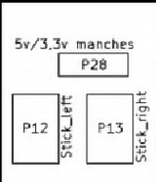
Note : VL = Vertical Left, HR= Horizontal Right
Assignment of sleeves

P12 P13

VL HL VR HR

Assignment of potentiometers for mode 1 and mode 2


Gain Ailerons
Gain Rudder
Zero Ailerons
Zero Rudder
Gain Throttle
Gain Elevator
Zero Throttle
Zero Elevator
Gain Elevator
Zero Elevator
Gain Throttle
Zero Throttle
Gain Rudder
Gain Ailerons
Zero Rudder
Zero Ailerons

Preferably start with the throttle stick (RV mode 1, LV mode 2)
For Mode 1, Preset RV3 and R30 in the middle of the range.
Using a multimeter:
a) stick in neutral, on the corresponding pin of the Core circuit (Pin 51) measure the voltage then adjust to about 2.5v by turning on RV2.

Core / Pin Number Stick in Mode 1 and Mode 2
51 | Analog pin 8 | Stick RH | Stick RH_Ailerons | Stick_Rudder
53 | Analog pin 10 | Stick RV | Stick RV_Throttle | Stick LV_Elevator
54 | Analog pin 9 | Stick LV | Stick LV_Elevator | Stick RV_Throttle
56 | Analog pin 11 | Stick LH | Stick_Rudder | Stick RH_Ailerons

b) then move the stick to + 50%. (right for the horizontal sticks and at the top for the vertical sticks).
The voltage should increase and if this is not the case, see page 10 and reverse the supply direction of the stick, if it is a potentiometer.

Warning | Due to the varying range of sticks, it may be necessary to adapt the gain of the 4 amplifiers by modifying R 11, 12, 13 and 14.  (You can do this by putting the R30 gain pot in the middle of its range and look for the right value of R12 with a potentiometer in place of the resistor.
Set R27 to obtain about 4.5 to 4.8V with the handle at max. If you can not get this voltage and your voltage is higher, it is that your stick has too much variation of the signal and you will decrease the amplifier gain by replacing R30 (120k) by a lower value. (47K - 68K should be suitable)

c) Max. stick, then adjust the voltage to 4.90V max using potentiometer R27.
d) Check that you have about 0.1V at the lower end of the stick.

If the variation is not the same in both directions, then there is nothing to do. It is the linearity of your knob potentiometer that is in question, but it is not serious ... the software will then adapt.
Perform the same procedure for the other sticks without seeking precision since we will adjust these values ​​more finely thereafter.
At the end of the fourth, you should master the method!
In any case, you will need to calibrate the sticks when starting the transmitter as shown in the "Calibration" view on the next page.

6.3.2 Method 2
More practical to carry out, it can only be done if the transmitter is already operational.
• Access the "ANAS" 6/7 screen of the radio and consult the values delivered by each stick.
- With the stick at neutral, set the zero knob to obtain 0400 (H) points.
- With the stick at lowest end, set the gain knob to get 0020 (H) of the converter.
Check the maximum point: if your potentiometers are linear, you should get a value close to 07E0.
Note: It may be necessary to resume settings if you need to adjust a large variation.
In any case, end with a neutral setting at 0400,

Then the Calibration" function will be carried out, whose goal it is to take the exact values ​​of points of the neutral and each direction of each of the sticks, to assign them coefficients in order to allow precise calculations on the trims, the mixings , display, etc., and of course the calculation of the pulse width.
In the end, a round will vary from -100% to + 100%
On the next view, "Ail" is on a black background, which shows a saturation of the signal, the mini voltage of the stick is too low which shows that the gain is too high on this way.




7 Screen preparation:

7.1 Recall pinout for P16


Pay attention to the cable for P16 when you wire it up since it might be in the wrong order (2,1,4,3, etc)

7.2 Screen Zollen (7565P)
Ideal screen for the reuse of small / medium cases
Info | If when you turn on the 7565P, your screen looks dark, do not worry, look at it sideways and try to access the contrast setting that may be "stuck" at 30.  Going back to an intermediate value, your screen should be more visible!



Choose ST7565P in Desktop.
5V power supply.

Desolder R4 (80) and bridge R6 (68).

Arrangement of the connector P16 (2 lines of the top) to the pin layout of the Zolen (2 lines of the bottom + diagram)
1 | 2 | 3 | 4 | 5 | 6 | 7 | 8 | 9 | 10 | 11 | 12 | 13 | 14 | 15 | 16 | 17 | 18 | 19 | 20
 | Vdd | +5V |  |  | DB0 | DB1 | DB2 | DB3 | DB4 | DB5 | DB6 | DB7 | RD | WR | D | RST | A_Lcd |  | CS
NC | 10 | 9 | NC | NC | 1 | 2 | 3 | 4 | 5 | 6 | 7 | 8 | 16 | 15 | 14 | 13 | 11 | NC | 12


With this screen RV6 is not necessary.
RV1, will allow the brightness adjustment, the contrast being set by software.
Note: In the documentations, it is planned to insert a R of about 100 ohms in the line LCD_Light: this resistor is already in place on the Circuit (R10)

7.3 Screen ARTRONIC (7565R)
Choose ST7565R in Desktop.3.3V power supply. Connector P16

To end



7.4 Screen ST 7920 :


Choose ST7920 in Desktop.
5V power supply.
Arrangement for P16 (top line) to ST7920 display pinout (type 12864B V2.0) (bottom line):
1 | 2 | 3 | 4 | 5 | 6 | 7 | 8 | 9 | 10 | 11 | 12 | 13 | 14 | x | 15 | 16 | 17 | 18 | 19 | 20
GND |  | +5V | V0 | Vout | DB0 | DB1 | DB2 | DB3 | DB4 | DB5 | DB6 | DB7 | RD | PSB | RW | RS | RST | Bla  LCD | Blk  Lcd | Cs
1  Vss |  | 2 | 3 | 18 | 7 | 8 | 9 | 10 | 11 | 12 | 13 | 14 | 6 | 15 | 5 | 4 | 17 | 19 | 20 | x



Info | This screen is particularly suitable if you have a Multiplex 30xx or 4000 transmitter box

Info | Pin 15 (PSB) of the display must be connected to + 5V to set the parallel mode.

7.5 Screen KS108B :
Warning | There are several models of KS108 screens.  Our is the KS108 "B": Screen dimensions 61 * 44 mm    
Choose KS108 in Desktop. 5V power supply.

Arrangement for the P16 connector (top line) to the pin assignment of the KS108A (bottom line of the table):
RV1, RV6 and R10 are on the shield
1 | 2 | 3 | 4 | 5 | 6 | 7 | 8 | 9 | 10 | 11 | 12 | 13 | 14 | 15 | 16 | X | 17 | 18 | 19 | 20
GND | GND | +5V | V0 | V  out | DB0 | DB1 | DB2 | DB3 | DB4 | DB5 | DB6 | DB7 | RD | R/W | LcdA0 | R/W | RST | Bla  LCD | Blk  Lcd | Cs
3 | 3 | 4 | 5 | 18 | 9 | 10 | 11 | 12 | 13 | 14 | 15 | 16 | 8 | 1 | 6 | 7 | 17 | 19 | 20 | 2

Warning | Look out :  Pin 7 of the screen should be connected to ground by a 1 kohms Resistor.  If the display is reversed, switch CS1 and CS2. (Pin 1 and 2 on the screen)

7.6 Summary of Arduino, Ports, P16 and Display Connections
Note: Column 2560 is for information only
The table is ordered according to the number of the pins of P16

2560 | Core | Port | P16 | Signal | 7565P | 7920 | KS108
OV Gnd |  |  | 1 | Blk Display | 14 | 20 | 20
OV Gnd |  |  | 2 | Vss | 10 | 1 | 3
+5V Vss |  |  | 3 | Vdd | 9 | 2 | 4
NC | NC | X | 4 | Vo or Vr (pt Medium RV1) | x | 3 | 5
NC | NC | x | 5 | Vee or Vout (towards 1 side of RV6) | x | 18 | 18
22 | 74 | A0 | 6 | DB0 | 1 | 7 | 9
23 | 71 | A1 | 7 | DB1 | 2 | 8 | 10
24 | 72 | A2 | 8 | DB2 | 3 | 9 | 11
25 | 69 | A3 | 9 | DB3 | 4 | 10 | 12
26 | 70 | A4 | 10 | DB4 | 5 | 11 | 13
27 | 67 | A5 | 11 | DB5 | 6 | 12 | 14
28 | 68 | A6 | 12 | DB6 | 7 | 13 | 15
29 | 65 | A7 | 13 | DB7 | 8 | 14 | 16
30 | 83 | C7 | 14 | /RD (or RD or E) | 16 | 6 | 8
31 | 84 | C6 | 15 | WR (or RW) | 15 | 5 | 7
32 | 85 | C5 | 16 | Lcd A0 (or RS, /DI) | 14 | 4 | 6
33 | 86 | C4 | 17 | :RST (or /RES) | 13 | 17 | 17
 |  |  | 18 | Midpoint RV6 | x | x | 19
35 | 87 | C2 | 19 | Led Backlight 100 ohms | 11 | 19 | 20
34 | 87 | C3 | 20 | /CS (CS1) | 12 | 16 | 1
 |  |  |  | (CS2 on KS108) | X | X | 2
 |  |  |  | PSB | X | 15 | x

Remarks | x |  |  | non-existent
KS108 | 1 | CS1 |  | Linked to Lcd_WR
 | 2 | CS2 |  | Linked to Lcd_Cs
 | 7 | R/W |  | Grounded by R 1k ohms
ST7920 | 15 | PSB |  | PSB signal to connect to + 5V
 | 16 |  |  | Not connected
 |  |  |  | No RV6 potentiometer
7565P |  |  |  | No RV6 potentiometer

8 Appendices :

8.1 Remove the TTL / RS232 converter from the FrSky DHT module.

The DHT module originally incorporates an RS232 <> TTL converter on the telemetry link.
This link is also used for updating the firmware of the module.
If you no longer want to update this module (there will be more new versions anyway) it is advisable to remove this converter, which will allow to directly connect these signals to the input telemetry outputs and avoids the RS232 / TTL converter wiring described on page 7 of this document.

In the end, the operation is relatively simple:
Locate the Tx and Rx exit points on the map
• On the circuit board, cut the two tracks arriving at these two points
• (the two yellow lines near C21 and R19)
• Directly connect Tx and Rx to the points shown in the following view
• It will of course be necessary to bridge the connections that are no longer made by the converter on the card by connecting the following points:
• Note: The blue link in the receive line is a 220 ohm resistor
NOTE: If you are using the 2.1 shield, connect these points crosswise (1> 5 and 2> 6) to account for the error described at the beginning of the document




9 Placement of components :

10 Various Tips
- Solder BT1 (clock battery connector) with an angled connector coming out under the JQ6500 (beware of short circuits with the pins of the core).
- Do not wire your SD card until you have tested all functions as it may block access to the F-Ram and clock if one of them fails.
- if your I2C port does not work (the F-Ram, the DS3231 clock and the SSD1306 use it), this can come from the defective DS3231. In this case, lift the legs 15 and 16 (sda and scl).
- For the adjustment of 4 sticks, there are 4 SMD pads (W1 to W4 solder side). For my part I preferred to place my multimeter tip on the legs 1,7,8 and 14 of the MCP604. This avoids turning over the shield.
Another solution: Place yourself on the corresponding pin of the Core circuit to benefit from a "non-slip" contact, see page 21.
- Some of us had problems with false contacts. A toothbrush with either alcohol to burn (my preference) or acetone (a strong one to my taste) can help you clean the shield of any solder particles.
- The PM-5033 is not easy to stock. The small DC-DC converter which is planned in double implantation of the 5v, can be an alternative solution. For easy installation, solder 4 two-point connectors on the shield (IN +, IN-, OUT + and OU-), then solder 4 x two-point connectors under the converter. Then solder all of the 4 connectors of the shield over the 3 large capacities.

If you notice any errors (and there are some), please contact me (pierrotm77) through the forum posts

